English preschool
Name: ____________________________________________ Date : July 27th
Sailing in my boat
Color the vocabulary of the song
(Colorea el vocabulario de la canción)
Boat 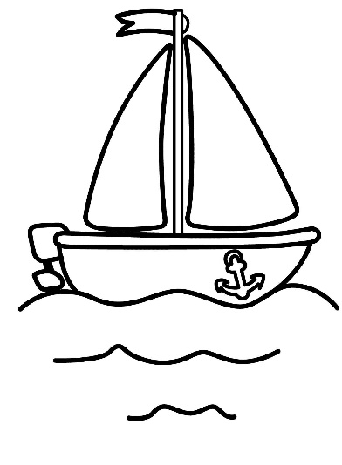 Moon

stars birds

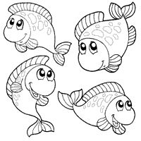

Fish

