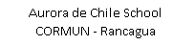
English Worksheet – Bastián González (Teacherbastiangonzalez@gmail.com)
Unit 1: Feelings and opinions
Name:__________________________________________ Grade: 7º _____

Date: _____________________ How do you feel today? I feel ___________________
Unit 1 – Feelings and opinions
Good Morning/afternoon/evening, my lovely animals! Espero que sigan muy sanos en sus casas. En esta guía seguiremos trabajando en la unidad uno, en la que trabajaremos los sentimientos y opiniones, lo cual me parece un tema bastante relevante para su desarrollo personal, por lo que trataremos de ahondar no sólo en vocabulario.

Para cualquier duda o revisión del material, dejo un mail de contacto. Solamente responderé dudas con respecto a las actividades. Les recuerdo también a mis queridos alumnos que ustedes son los que tienen que encontrar las respuestas, mi trabajo es ayudarlos a llegar a ellas.

Objectives:
• To identify feelings and emotions
• To understand a text and the concept of empathy

Para la siguiente actividad, tienes que poner a prueba esa misma capacidad, identificando en estas caras los gestos que nos indican estados de ánimo y sentimientos.

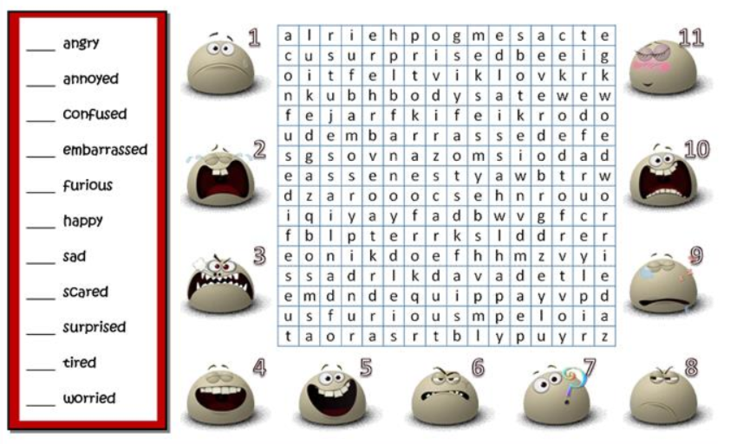
I.- Find the feelings and emotions in the wordsearch, then match the feelings and the numbers.

II.- Match each feelings with the 3 that have a similar meaning.

1.- Dissapointed | ___ Anxious – Worried - Tense
2.- Sad | ___ Akward – Uncomfortable - Uneasy
3.- Embarrassed | ___ Saddened – Upset – Let down
4.- Nervous | ___ Defeated – Irritated - Annoyed
5.- Mad | ___ Satisfyed – Pleased - Happy
6.- Proud | ___ Isolated – Alone - Friendless
7.- Frustrated | ___ angry – Furious - Crazy
8.- Lonely | ___ unhappy – Sorrowful - Depressed
En la siguiente actividad, nos pondremos en el lugar del otro, identificando los sentimientos y el cómo reaccionar a ellos.
Read the 8 situations
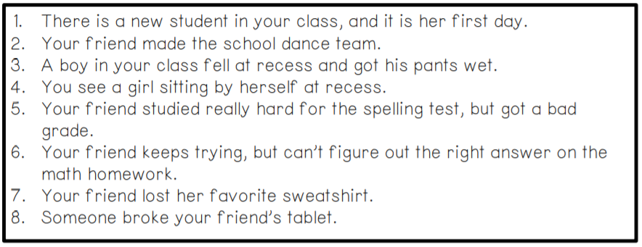
We have 8 different feelings and 8 different ways in which you can respond
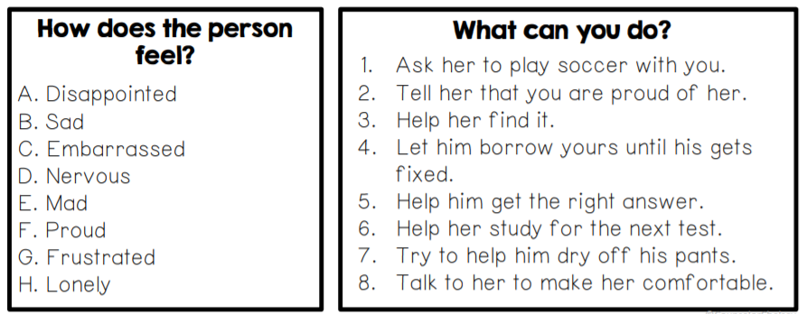
Activity III.- Read the situations and match them with correct feeling and response.
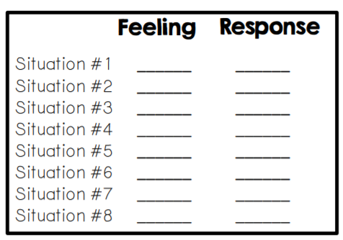

You have done an amazing job!

