English Worksheet – Bastián González (teacherbastiangonzalez@gmail.com)
Review – Unit 1: My world
Name:__________________________________________ Grade: 5º _____

Date: _____________________ What time is it? It’s ________________________
Unit 1 – My world
Good Morning/afternoon/evening, my lovely animals! Espero que sigan muy sanos en sus casas. En esta guía seguiremos trabajando en la unidad uno, en la que trabajaremos las rutinas diarias que tienen en sus casas, y así ahondar más en el concepto de tiempo que trabajamos anteriormente.

Para desarrollar esta guía, son necesarias las explicaciones del PPT y el vocabulario que ahí se encuentran. En el PPT encontraran instrucciones de cuándo y cómo hacer las actividades de forma secuencial.
Si pueden trabajar con un teléfono a mano o un computador, no será necesario imprimir el PPT. Recuerden tomar nota en sus cuadernos o en la parte de atrás de esta guía si la imprimen. De la misma manera, no es estrictamente necesario imprimir esta guía. Toda actividad de ella se puede desarrollar en el cuaderno.

Para cualquier duda o revisión del material, dejo un mail de contacto. Solamente responderé dudas con respecto a las actividades. Les recuerdo también a mis queridos alumnos que ustedes son los que tienen que encontrar las respuestas, mi trabajo es ayudarlos a llegar a ellas.

Objectives:
• To express daily routines
• To know and apply present simple rules

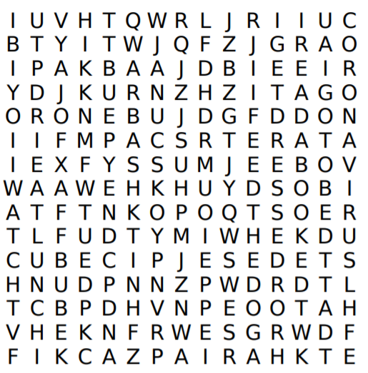
I.- Find the 10 routines in the wordsearch. Write the ones you find.

1- I brush my teeth
2- _______________________________
3- _______________________________
4- _______________________________
5- _______________________________
6- _______________________________
7- _______________________________
8- _______________________________
9- _______________________________
10- ______________________________

II.- Write a Schedule with 10 of your daily routines and the hours.
Time | Routine | Time | Routine
1.- |  | 6-
2.- |  | 7-
3.- |  | 8-
4.- |  | 9-
5.- |  | 10.-

III.- Add -S, -ES or -IES to each verb.

1.- Play ___________________
2.- Take ___________________
3.- Brush ___________________
4.- Get ___________________
5.- Wake ___________________
6.- Eat ___________________
7.- Work ___________________
8.- Study ___________________
9.- Feed ___________________
10.- Watch ___________________
IV.- Create a schedule for any member of your family or friend with 6 of his/her routines and the time.
Time | Routine | Time | Routine
1.- |  | 4.-
2.- |  | 5.-
3.- |  | 6.-

