

COLEGIO AURORA DE CHILE

CORMUN RANCAGUA 2020

English4° grade worksheet N°1

Name _________________________________ Date: March18th

1. School subjects Escribe en español las siguientes asignaturas

|  |  |  |  |
| --- | --- | --- | --- |
| **PE.** Physical education | Math | Art | Spanish |
|  |  |  |  |

|  |  |  |  |
| --- | --- | --- | --- |
| Science | Music | English | IT = information technology |
|  |  |  |  |

1. Look at the picture and write the subject (observa el dibujo y escribe la asignatura)



**______________**



**______________**



**_______________**



COLEGIO AURORA DE CHILE

CORMUN RANCAGUA 2020

English4° grade worksheet N°2

Name _________________________________ Date: March18th

**word Scramble**

**School Subjects**

**Unscramble the words below:**



1. amht________________

2. nishspa________________



3. ep_______________



4. hsilegn_______________



5. nescice________________



7. cuism________________

8. ti_______________

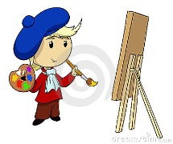

9. tar________________