**Word Search**

A U N M Z P E N C I L R

P E N Z Q T Y G O B B U

L V X B O O K L A Y K L

S B A G P L R U C T D E

Z O P L M W I E P S D R

G H Q E R A S E R Y Z N

Find:

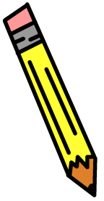 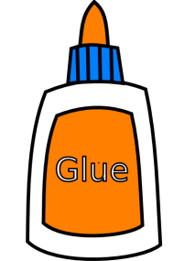 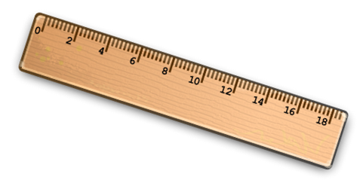   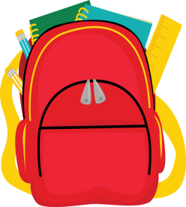

Pencil glue ruler book rubber schoolbag