COLEGIO AURORA DE CHILE
CORMUN RANCAGUA 2020
English1° grade worksheet N°1

Name _________________________________ Date: March18th

- Choose and circle, ( encierra la palabra correcta )

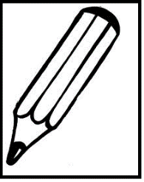
- This is a schoolbag / pencil

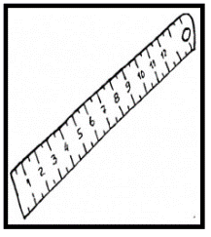
- Thisis a rubber / ruler

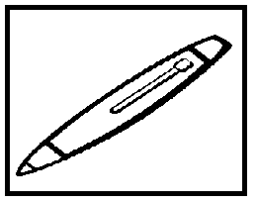
- Thisis a pen / book

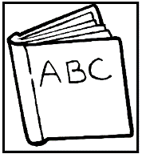
- This is a rubber / book

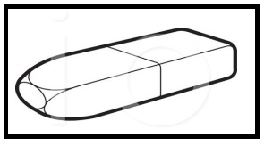

- This is a rubber/ ruler

COLEGIO AURORA DE CHILE
CORMUN RANCAGUA 2020
English1° grade worksheet N°2

Name _________________________________ Date: March18th

- Look,draw and color ( observa, dibuja y colorea )

It’s a ruler | It’s a pencil | It’s a rubber

It’s a schoolbag | It’s a book | They are scissors

